Step-by-step overview of working with PowerBI

WEEK 1 Task

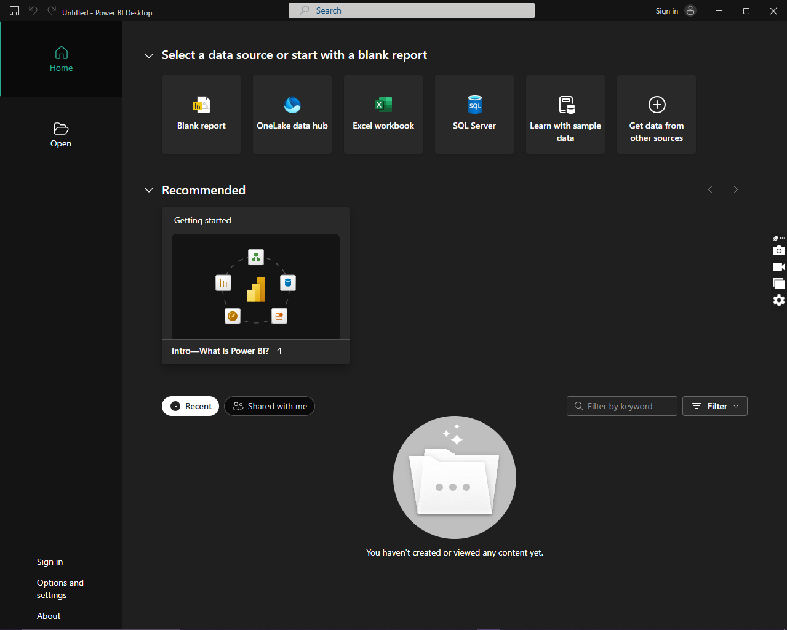

**STEP1: Install PowerBI Desktop and open the application after doing the necessary setup.**

After that click on **Blank Report** option.

A window like the one below will appear.

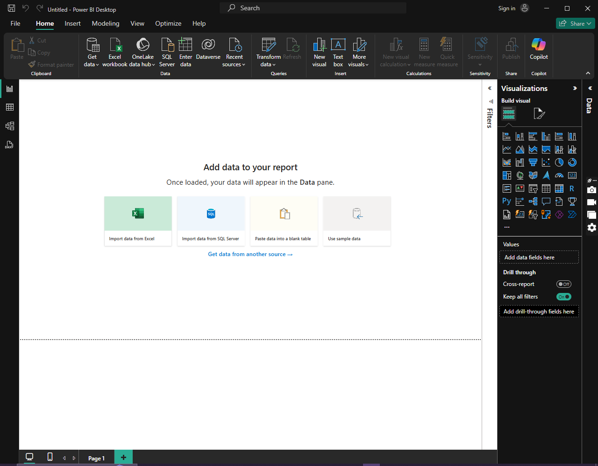

Note: The White area is called the **Canvas.**

**STEP 2: Accessing A CSV(Comma Separated Value) file on PowerBI**

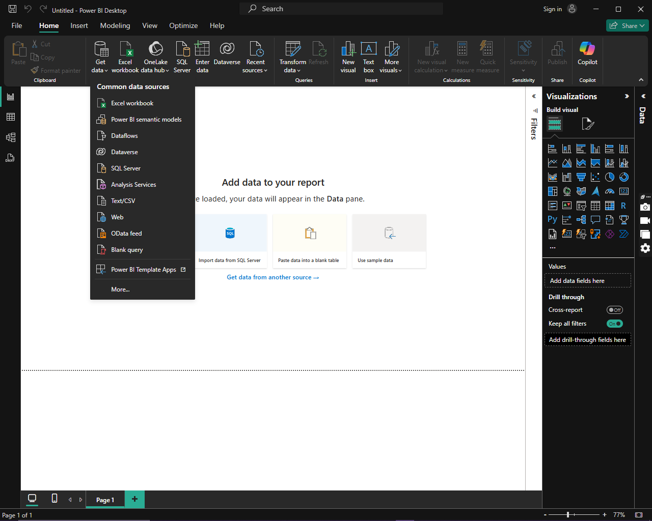

[Grab your reader’s attention with a great quote from the document or use this space to emphasize a key point. To place this text box anywhere on the page, just drag it.]

Click on **Get data** and from the dropdown select **Text/CSV** option

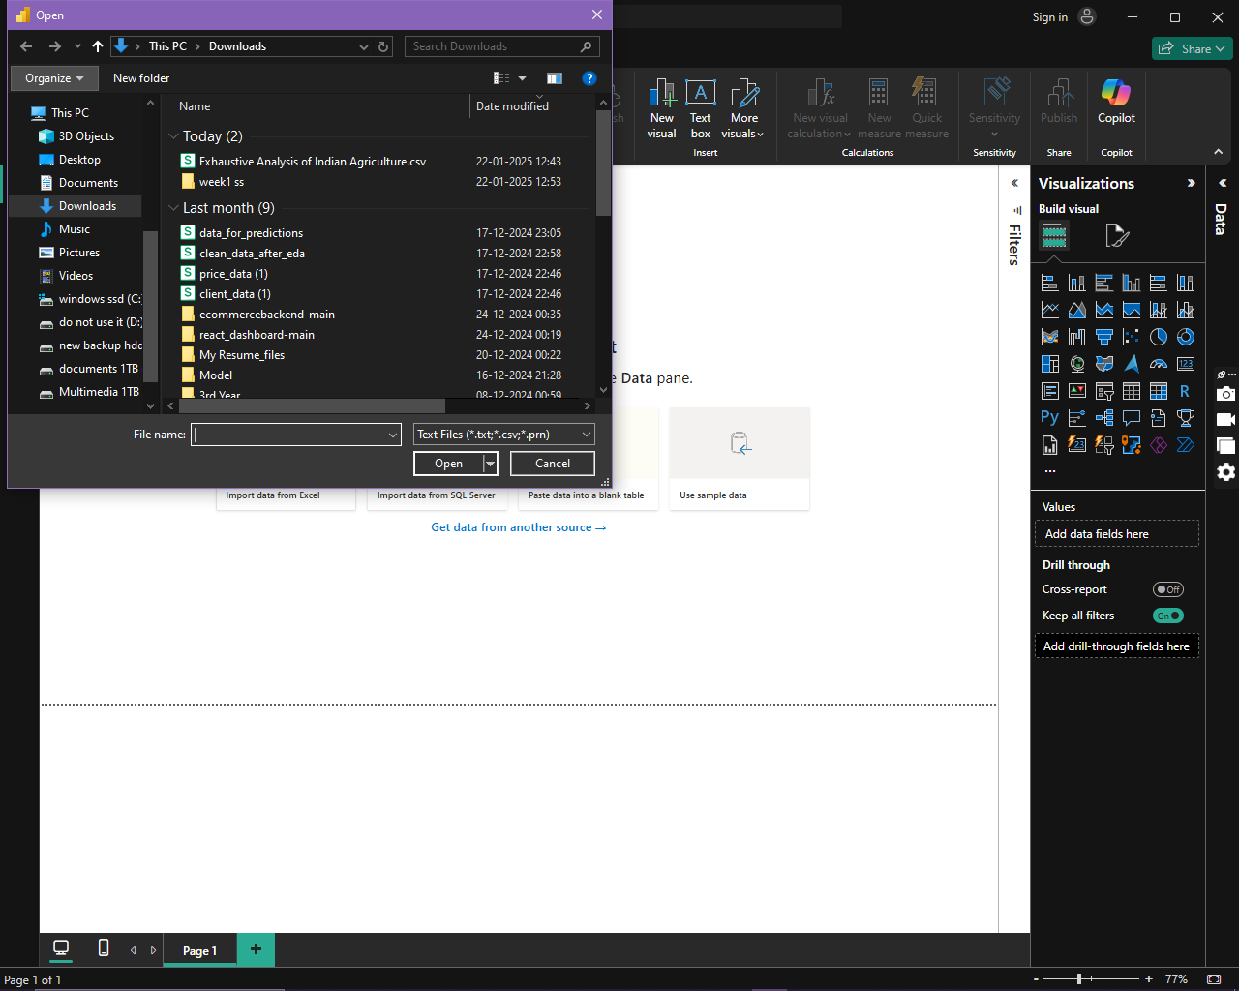

The **Open** dialogue box appears. Select the CSV file you want to open

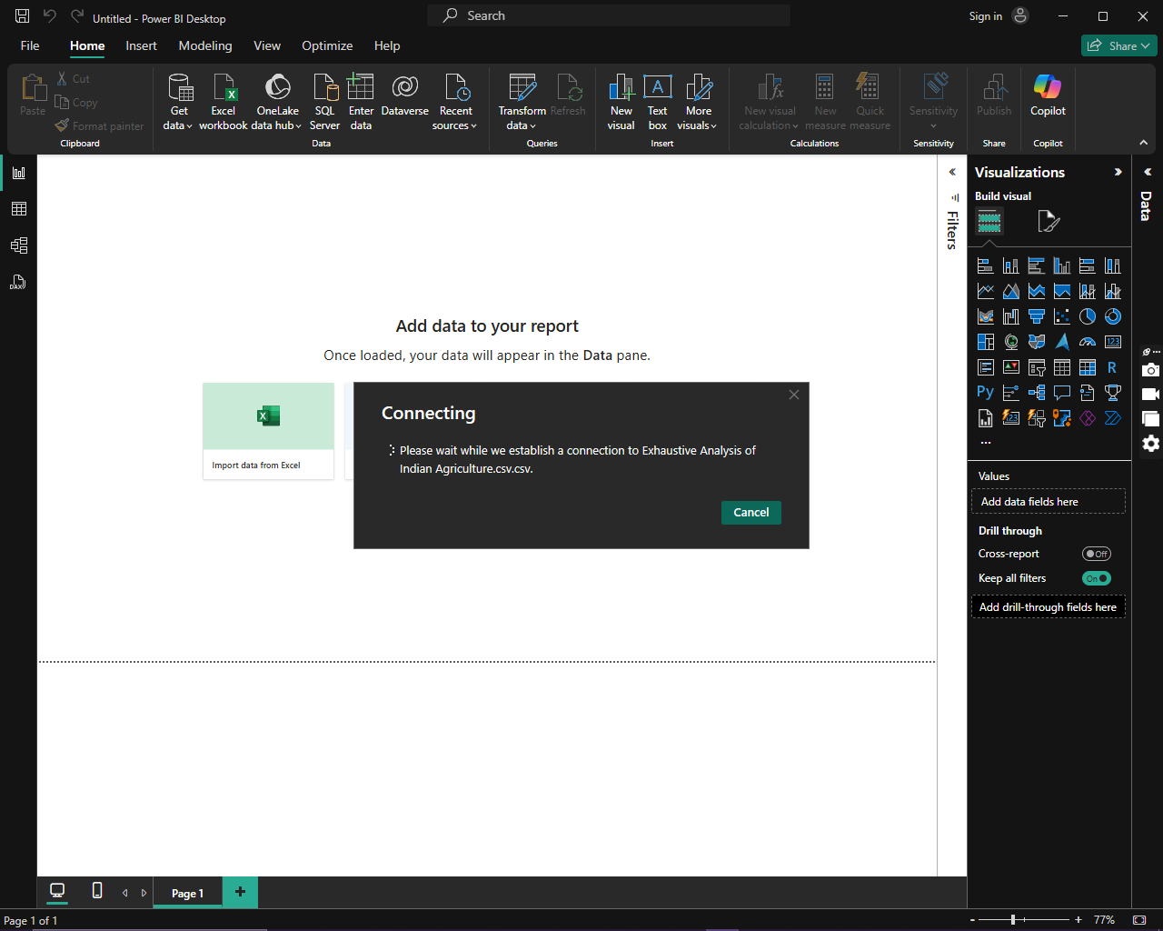The file then gets uploaded into PowerBI

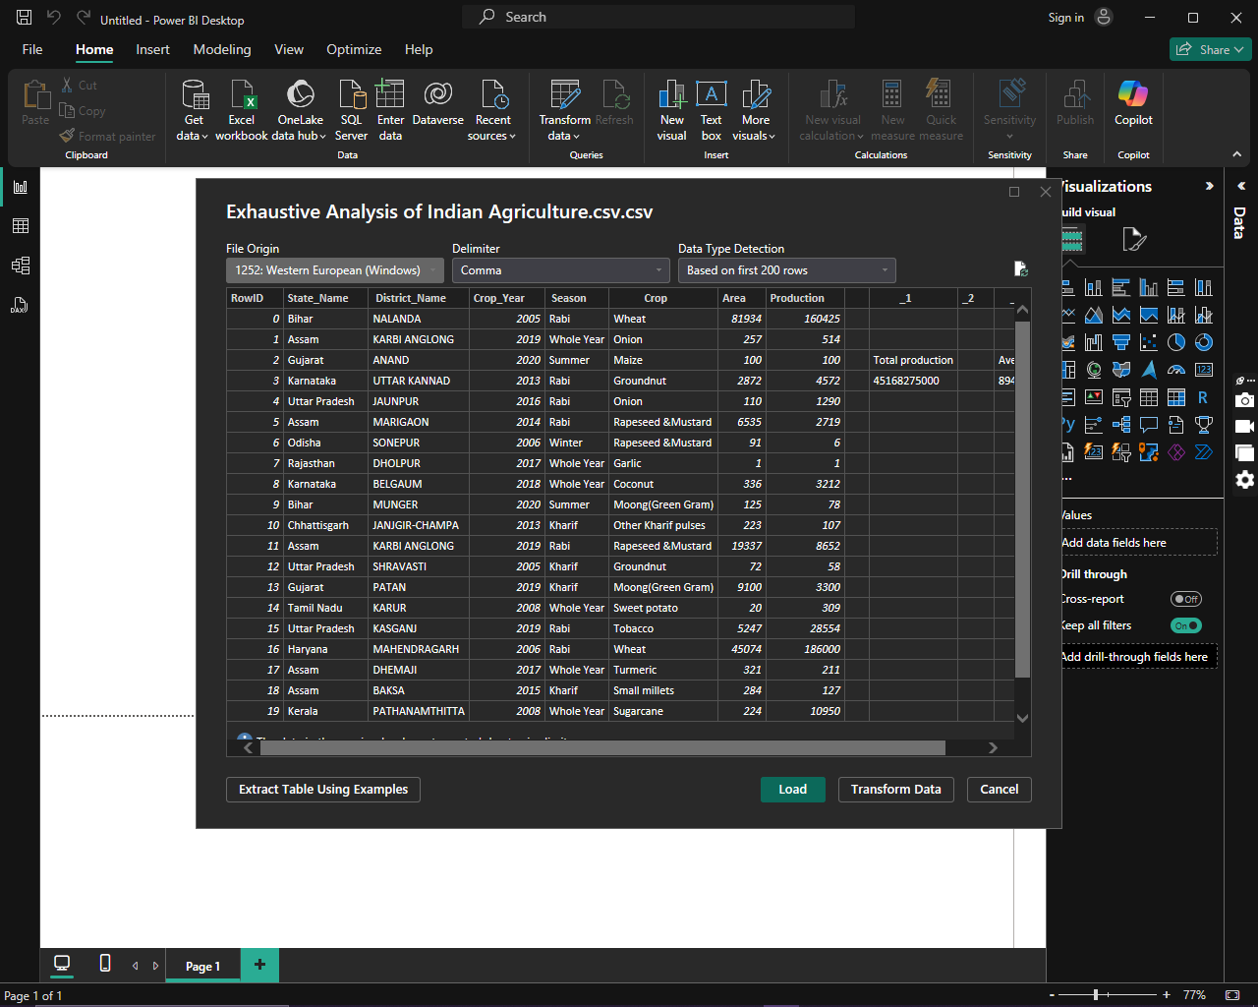The file then is successfully uploaded. Here we can either first transform the data or load it and then transform it according to our wish.

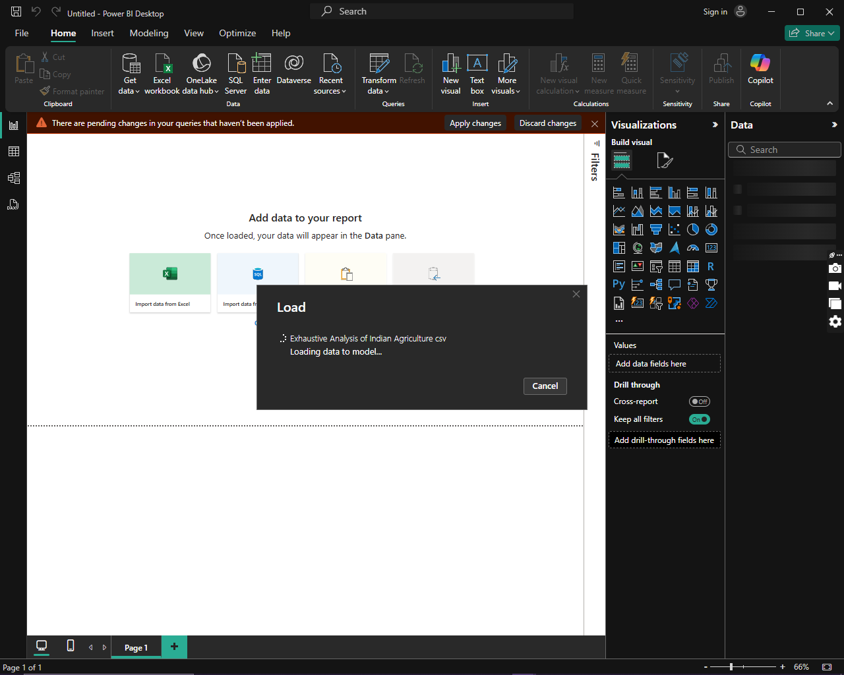We are loading the data first here.

As you can see in the image below it is being loaded.

Then a window like this appears where we can see our data and work on it.

**STEP 3: Editing the dataset.**

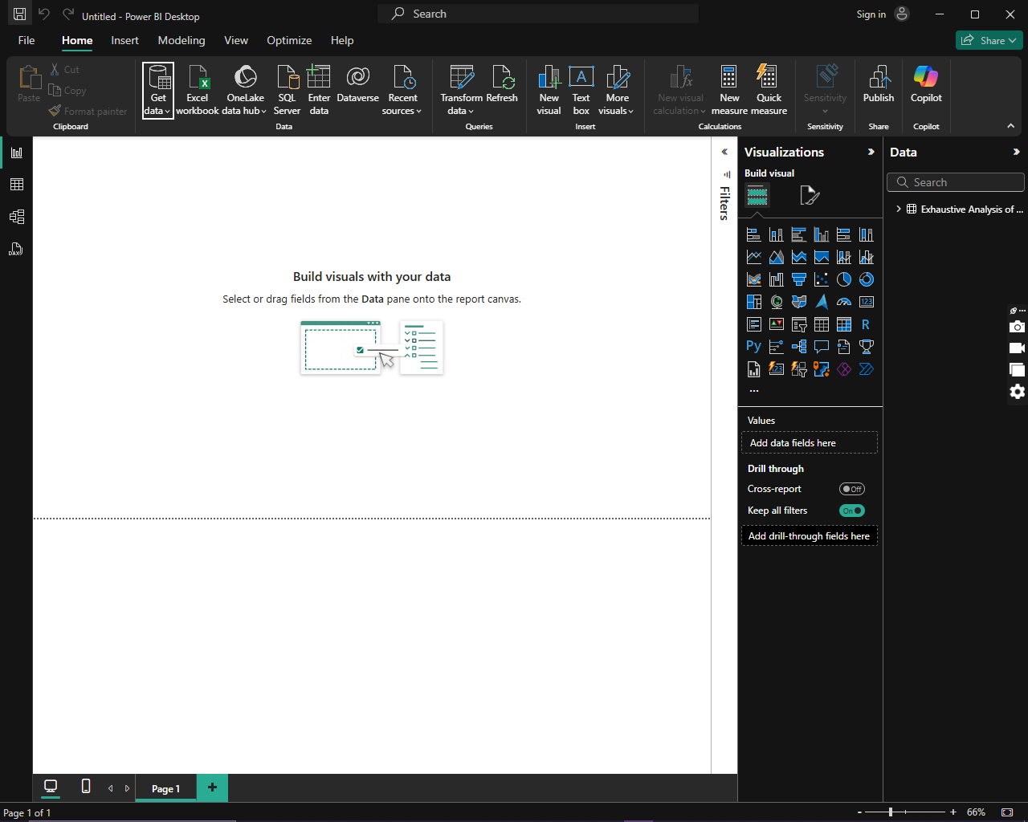

Click on **Transform data** option

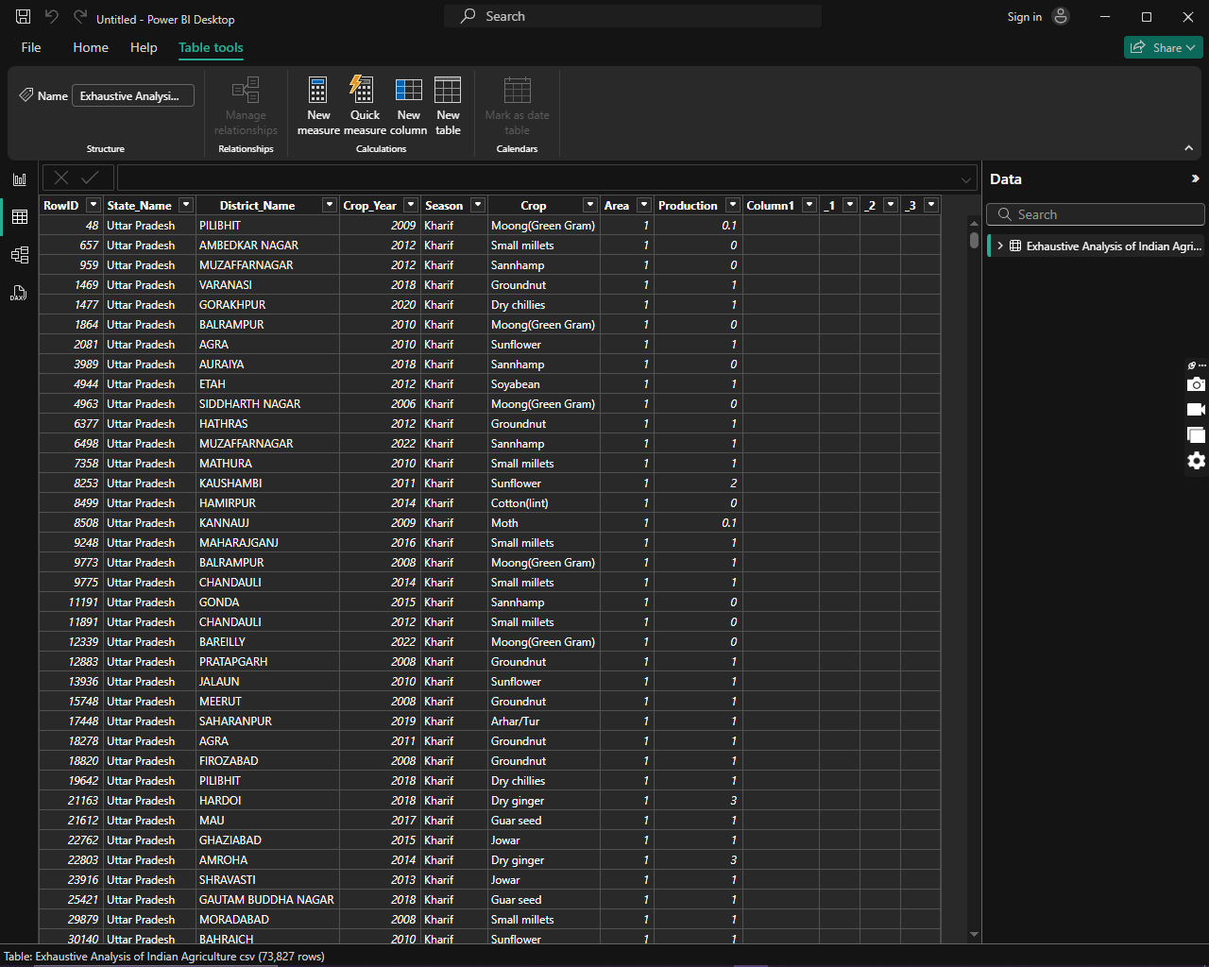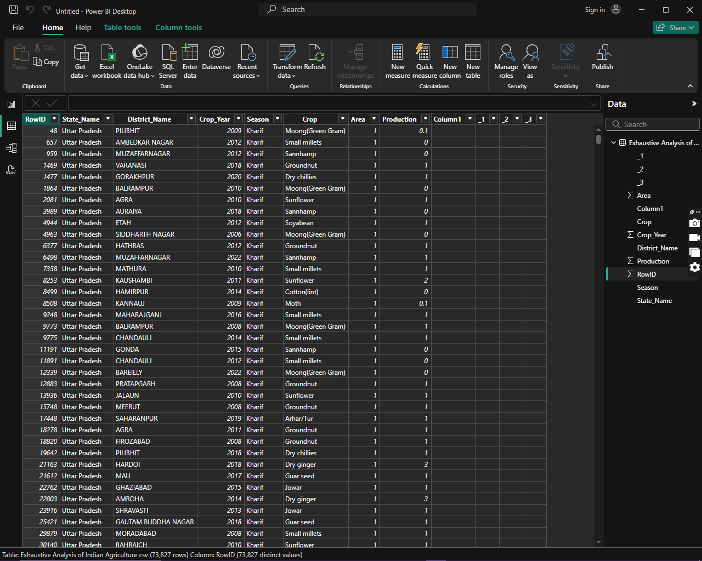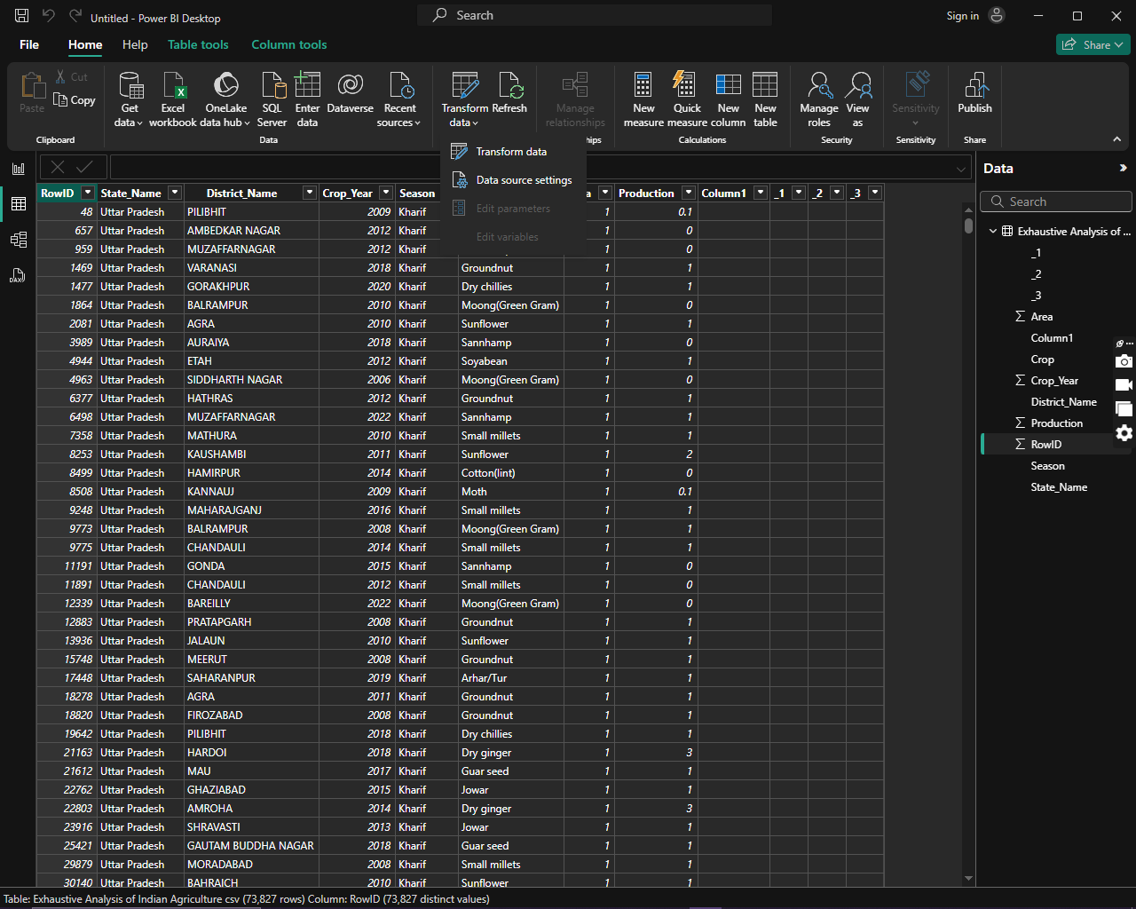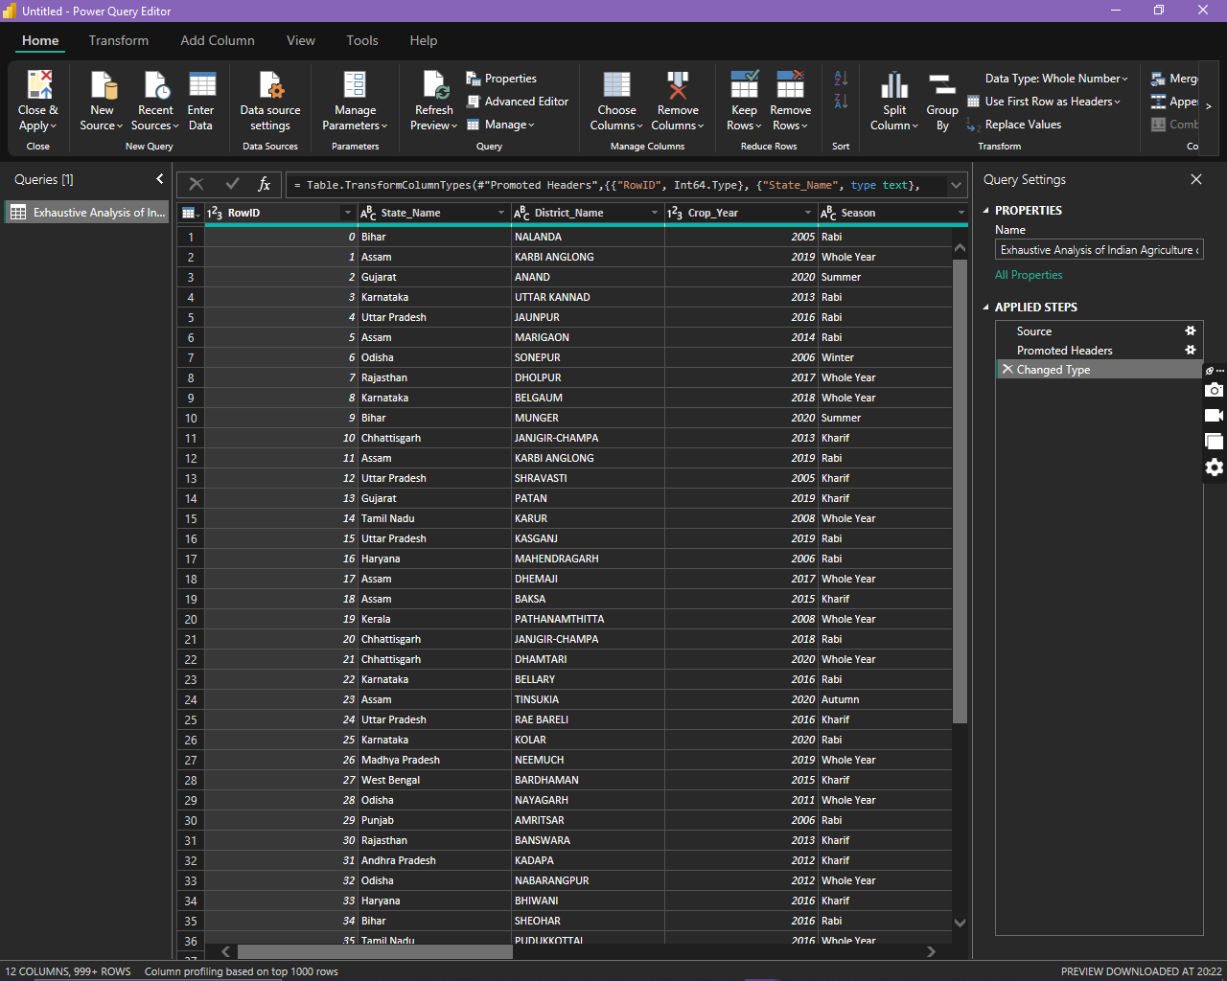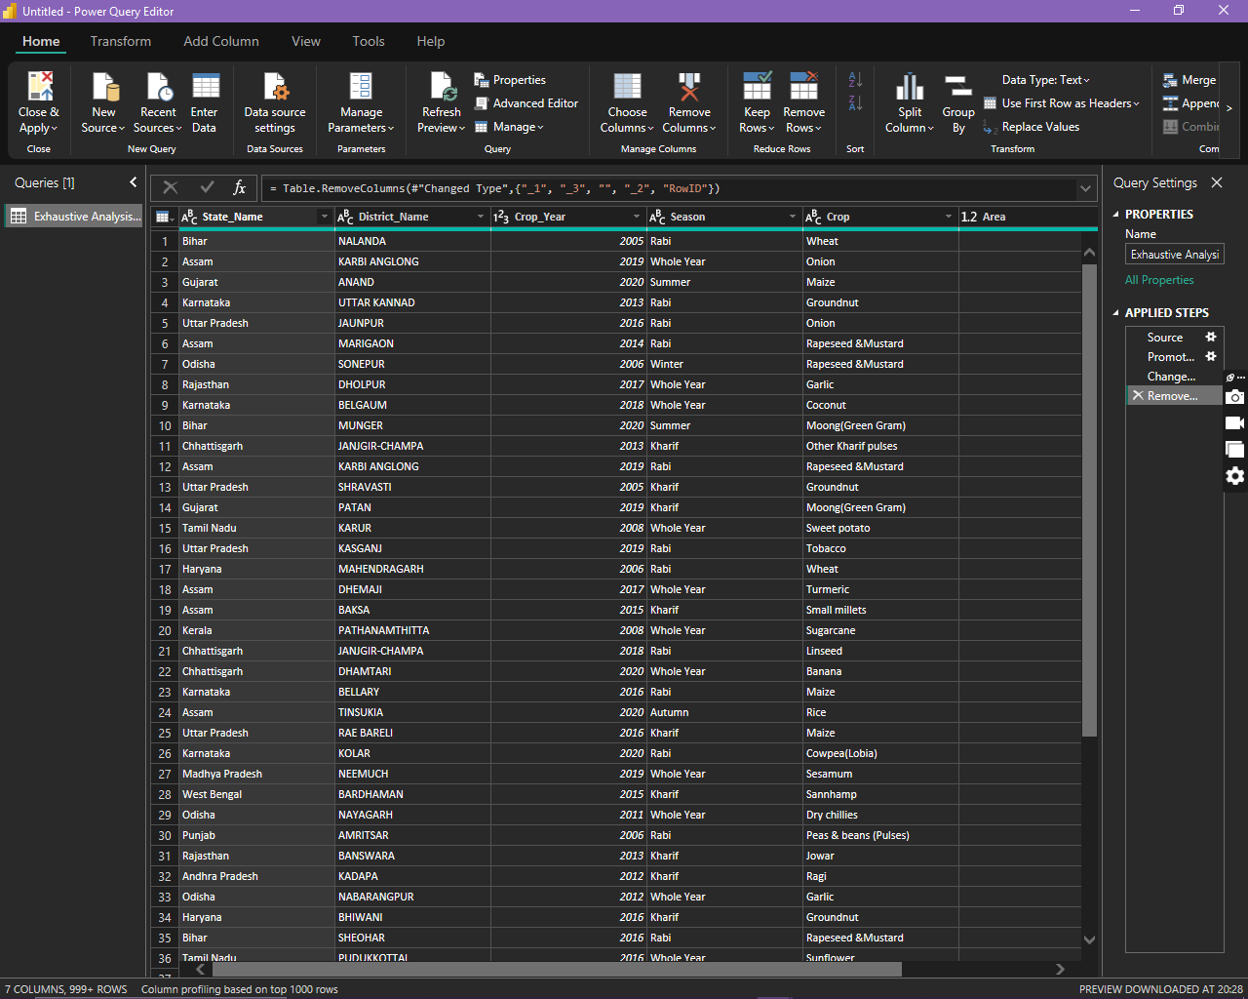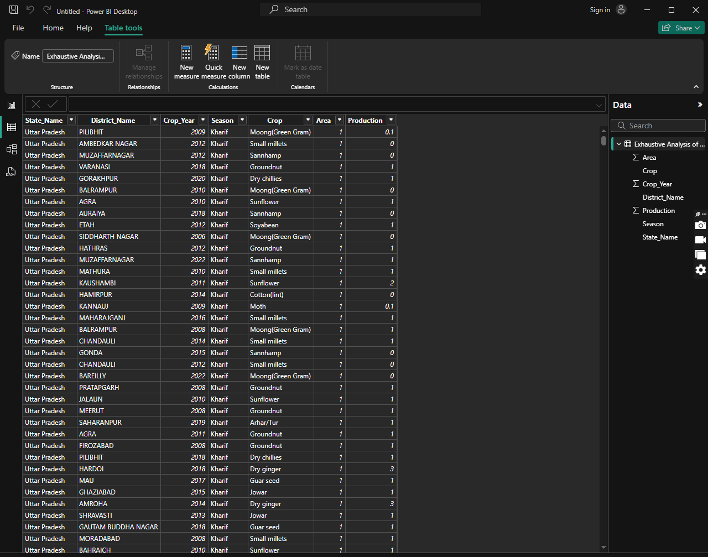

Next, we will be removing the unnecessary data such as empty columns, irrelevant figures, columns, and check for null values.

A window like this appears where we can edit our data.

Finally after all the editing click on **Close & Apply** option

As we can see that the dataset is now just as we wanted and is ready to use